Team Inventory

## September 27th, 2019

## Canopy - Team 11

**Sponsor:** Dr. Patrick Jantz

**Mentor:** Gerald Nowak

**Team Members:**

Robert Plueger

Nicholas Lopez

Dongyu Xia

Maria Granroth

## 

## 

## 

## 

## 

## 

## 

## Overview

The purpose of this document is to introduce the members of Canopy. Included for each member is their education, work experience, skills, and general interests.

**Biographical Info:**

**Name:** Robert Plueger (Lead)

**Major:** Computer Science

**Hometown:** Peoria, Arizona

**Education:**

**High school:** Sunrise Mountain High School

**GPA:** 3.95

**Institution(s):** Northern Arizona University

**Relevant Courses:**

* CS 386 - Software Engineering
* CS 421 - Algorithms
* CS 451 - Mechanized Reasoning About Programs

**Work Experience:**

None.

**Skills:**

* Mathematical and logical processes, obtained through various math courses and algorithm based classes.
* Considerable exposure to Java and C.

**Other Interests:**

I enjoy making music - both with instruments and digitally. I also enjoy playing a wide variety of video games.



**Biographical Info:**

**Name:** Dongyu Xia

**Major:** Computer Science

**Hometown:** Jiangsu, China

**Education:**

**High school:** Jiangsu Qingjiang Middle School

**GPA:** Chinese high schools do not have a GPA

**Institution(s):** Northern Arizona University

**Relevant Courses:**

* CS 386 - Software Engineering
* CS 345 - Principles of Database Systems

**Work Experience:**

None.

**Skills:**

* Learned HTML and CSS in CS 212.
* Learned Java in CS 249.

**Other Interests:**

I like swimming and reading. I like playing video games and sleeping.

**Biographical Info:**

**Name:** Maria Granroth

**Major:** Computer Science

**Hometown:** Gilbert, Arizona

**Education:**

**High school:** Gilbert High School

**GPA:** 4.6 weighted, 3.96 unweighted

**Institution(s):** Northern Arizona University

**Relevant Courses:**

* CS 499 - Research Methods for Software Engineering
* CS 399 - Advanced Web Programming
* CS 386 - Software Engineering

**Work Experience:**

* **Ticketmaster Internship.** My current project has been to update a web-based tool that grabs archives to run tests on. We had a side project over the summer that used machine learning to determine what Ticketmaster events to advertise and to whom.

**Skills:**

* Basic web programming (HTML, CSS, Javascript, Typescript) learned in CS 212, CS 399, and during my Ticketmaster internship.
* Agile software development learned in CS 386 and applied during my internship.
* Comfort in Java and Python from various NAU courses.

**Other Interests:**

I love animals and I have three cats. I care about environmental issues. If I have free time, I like to sew! I also play video games like Stardew Valley and The Sims.

**Biographical Info:**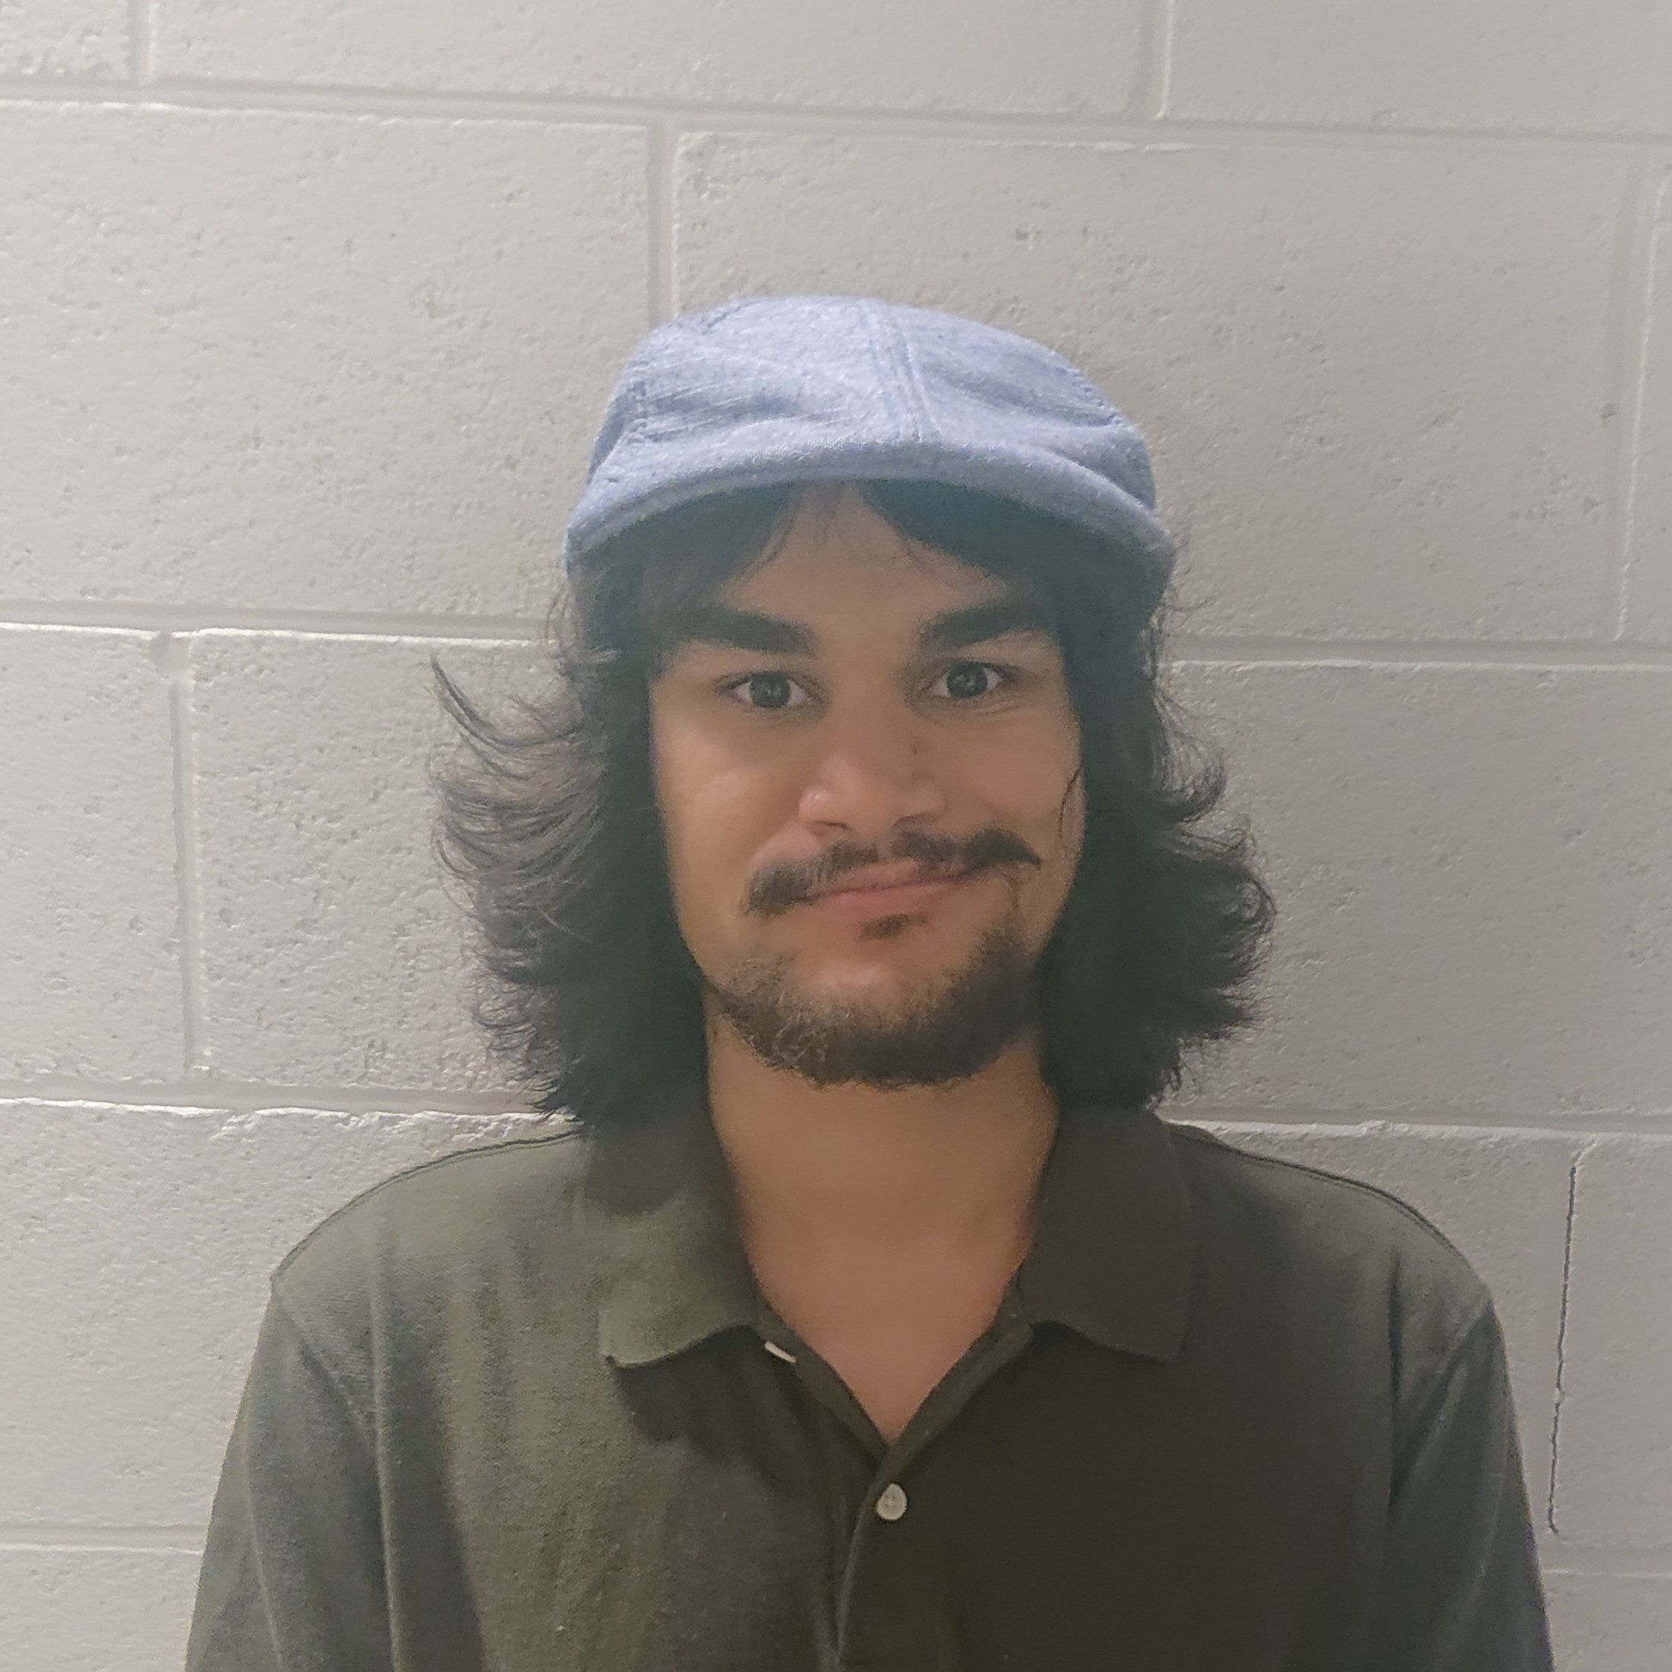

**Name:** Nicholas Lopez

**Major:** Computer Science

**Hometown:** Santa Clarita, California

**Education:**

**High school:** Hart High School

**Institution(s):** Northern Arizona University

**Relevant Courses:**

* CS 212 - Web Programing
* CS 386 - Software Engineering
* CS 451 - Mechanized Reasoning about Programing

**Work Experience:**

* **Web Page Author.** I am currently employed to build and maintain the **AZ***Trans* website for a research department here at NAU.

**Skills:**

* Basic web programming (HTML, CSS, Javascript, PHP) learned in CS 212 and current job.
* Good understanding of algorithmic thinking from CS 249 and other projects.
* Comfort in Java and C from various NAU courses.

**Other Interests:**

I spend most of my free time playing video games or tabletop role playing. I am a decent artist, but rarely get a chance to draw. I enjoy a nice hike through nature.